Section 22 (189): Backend Web Development
Backend Web Development: Server, Application, Database
Consists of three main components
- Server (computer)
- Application (where all the information is stored)
- Database (Allows to send and retrieve data)
Server
Is just a computer. For a live website it must be on 24/7 to receive incoming requests from anywhere in the world.
Local server (my computer – will not be on 24/7_
Applications
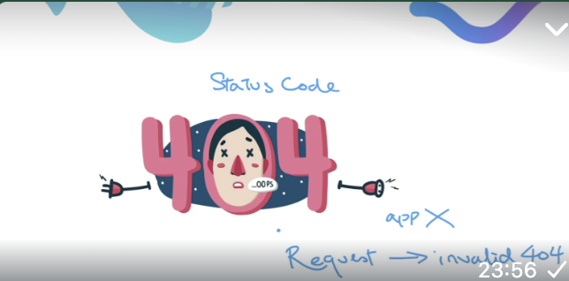
Logic determines how to respond to requests depending on requests. E.g, someone clicks a button for our Simon game – the application checks what the html button corresponds to and returns it to the user (e.g. level 2 or game over)

Database
Usually not needed by web pages (however it is needed by Web applications)
However, when your web applications get larger it will need to store user data. Like saving a word document. Our computer/server has a power, but our word document will not be saved without a database.

Web app vs webpage
Web app is more complicated.
Renders is based on html/CSS
The key difference between a website and a web app is that a website does NOT need a database as it doesn't need to save/store user data (passwords, emails, likes, retweets etc.) whereas a web app does.
E.g. A Word document is not a database because it is meant to be read, not queried or managed as structured data.
A web app must allow queries, updates, and management. If I enter my email it must store the information, a website would not.
A website does NOT change – it has pre-built html/js/css and that’s it. It isn’t interactive and does not have a database
Site landing page – web site
Simons game(on my github) – web app as it takes users demands, stores it and adapts (i.e. interactive)
BMI Calculator: Website and not web app
- When you input height and weight into a BMI calculator, the browser stores that data temporarily in memory to perform the calculation.
- Once you refresh the page or close the browser, the data is gone. Therefore it isn’t a web app as the data can not be retrieved

